Player Position Card – 4-4-2

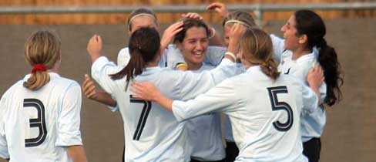
- 10

11 4 8 7

3 6 5 2

1

4-4-2

Roles & Responsibilities of Number 9 (Forward)

No. 9 – Forward

- Shoot At Every Opportunity With Power & Precision

- When Nearest Forward To Ball; Check Short And Try To Get On Half- Turn To Allow You To Play Forward (e.g. Rooney)

- When Farthest Forward From The Ball; Look To Get Across Pitch To Exploit Space Created In 2. (e.g. Bent)

- Play A High Pressure Game Against Opposition Centre Halves To Limit Their Ability To Play From The Back

- When Players In Wide Areas Shape To Cross; Switch Places With No.10 And Attack Cross With Pace, Power & Purpose

- Play Quickly & Cleverly In Tight Areas (i.e. Around Box)

